1. Print odd Numbers in an array

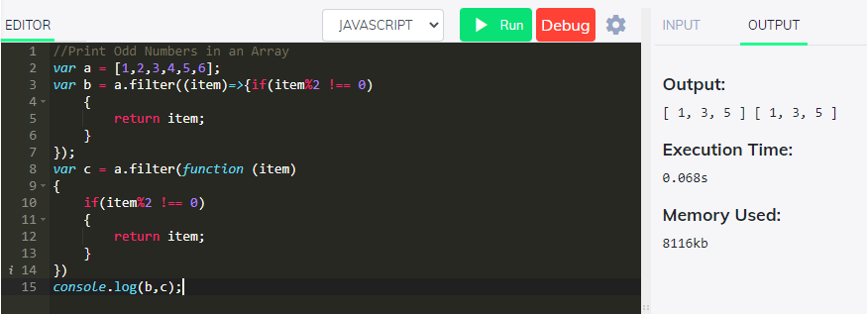

1. Sum of all Numbers in an Array

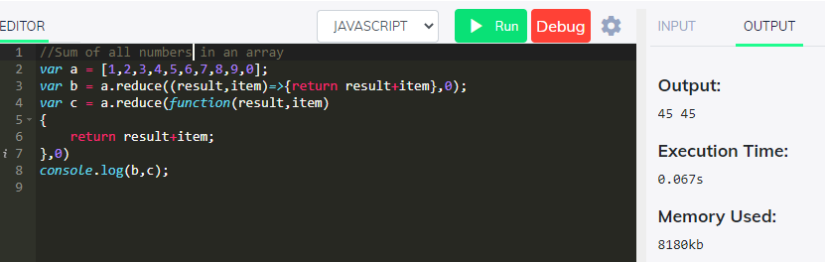

1. Return all prime numbers in an Array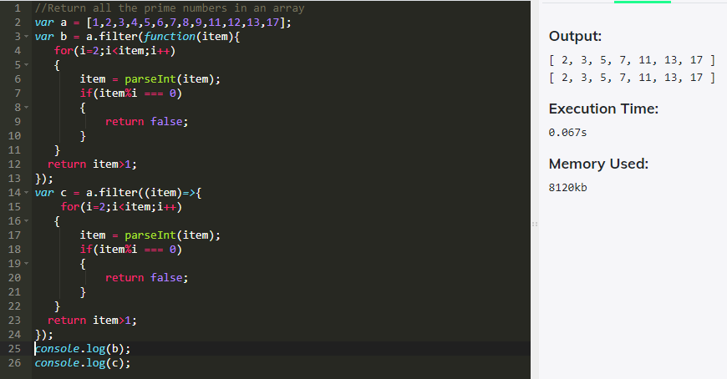
2. Remove duplicates from an array

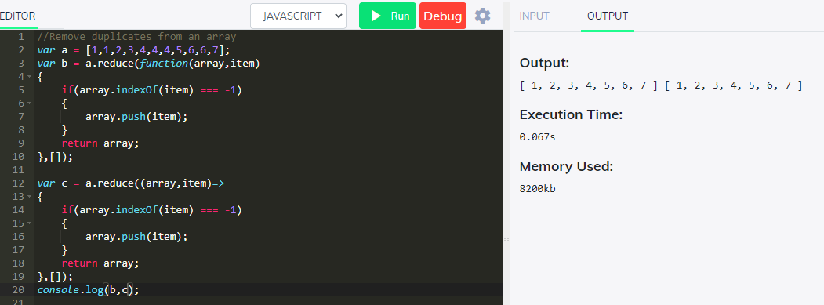

1. Rotate an array by K times and return the rotated array

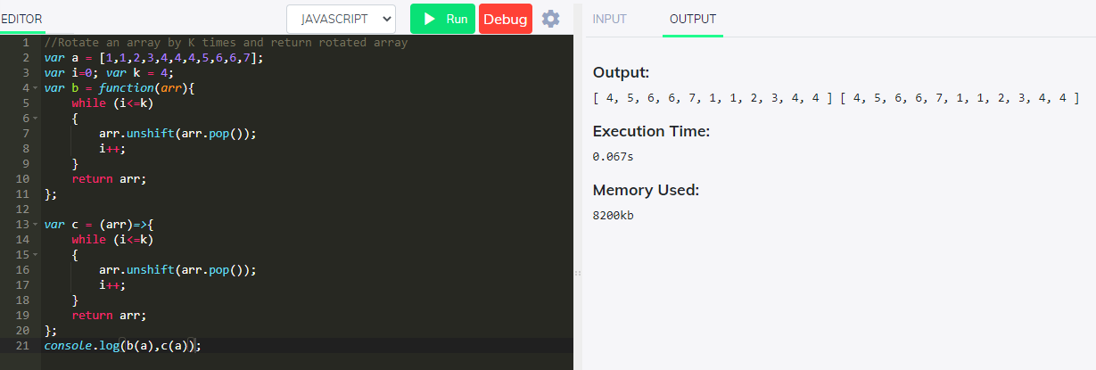

1. Return Median of two sorted arrays of same size

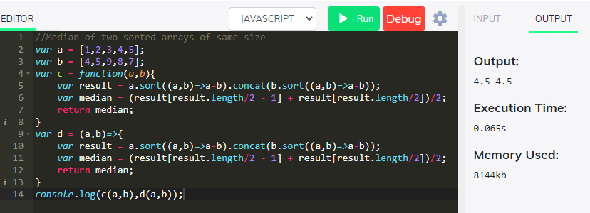

1. Return all the Palindromes in an Array

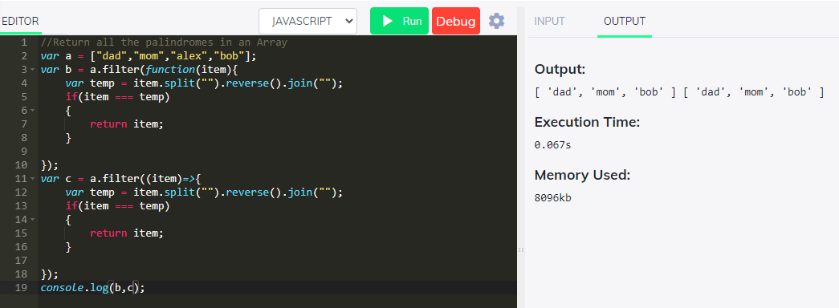

1. Convert all the strings to title caps in an array

